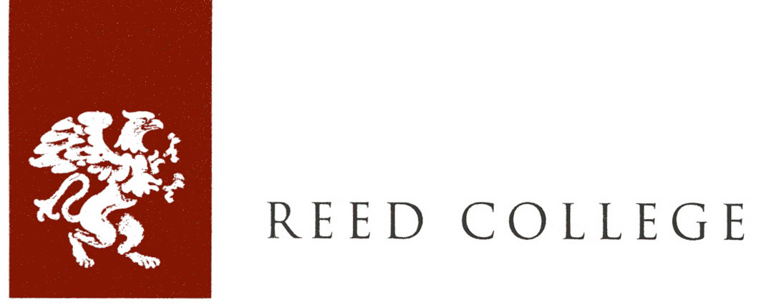

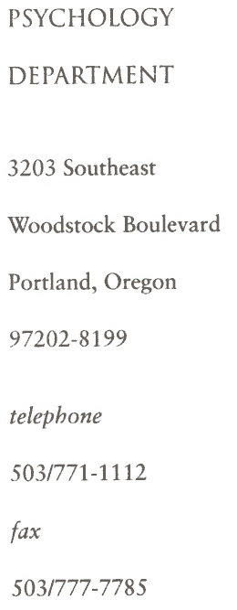

October 22, 2018

Dear Colleagues,

This letter is to verify that, for the purposes of determining membership status, Haoran (Matt) Wan is an undergraduate student at Reed College.

Sincerely,



Timothy Hackenberg
Professor of Psychology

